**ASSIGNMENT 2: DEBUGGING VISION TRANSFORMERS (ViT) WITH PYCHARM AND WSL**

**1. INTRODUCTION – ENVIRONMENT SETUP**

This report documents the debugging process of a **Vision Transformer (ViT)** model using **PyCharm** integrated with **WSL (Ubuntu)**.  
The experiment aimed to trace the model’s forward pass step by step — from patchification to classification — and record all tensor shapes using debugger snapshots.

**Environment setup included:**

* **IDE:** PyCharm Community 2024 with WSL integration
* **Python version:** 3.10.18 (Ubuntu)
* **Installed libraries:** torch, torchvision, transformers, numpy, pillow
* **Model used:** google/vit-base-patch16-224 from Hugging Face

The debugging was conducted using PyCharm’s built-in debugger.  
All **26 required snapshots** were captured showing tensor shapes and intermediate computations.

**2. INPUT IMAGE SELECTION AND PREPROCESSING**

**Selected Image:** A golden retriever dog (royalty-free, Unsplash)  
**Public link:** [Unsplash Dog Image](https://images.unsplash.com/photo-1552053831-71594a27632d?w=224&h=224&fit=crop&crop=center)  
**Description:** Single golden retriever facing the camera with a simple background — ideal for a clean feature representation.

**Preprocessing pipeline:**

1. Load the image using PIL.Image.open()
2. Convert to **RGB**
3. Resize to **224×224**
4. Normalize with **ImageNet mean/std**
5. **The original image**



1. Convert to a PyTorch tensor and reshape → (1, 3, 224, 224)

**3. VIT MODEL CONFIGURATION**

**Model:** google/vit-base-patch16-224

**Configuration:**

* Patch size: 16 × 16
* Embedding dimension: 768
* Attention heads: 12
* Encoder blocks: 12
* Classification head: 1000 classes (ImageNet)
* Input image: 224 × 224
* Number of patches: 196 (14 × 14 grid)

4. DEBUGGING PROCESS AND SNAPSHOTS

The debugging process involved setting breakpoints at 26 specific locations in the ViT forward pass. Each snapshot was captured using PyCharm's debugger, showing tensor shapes, values, and the current execution state. The following sections document all 26 required snapshots.

4.1 INPUT AND PATCHIFICATION

SNAPSHOT 1 - Raw Input Image Tensor

Shape: (1, 3, 224, 224)

Explanation: Batch of size 1, with 3 channels (RGB), resized to 224×224 and normalized with ImageNet statistics.

[SNAPSHOT 1 # 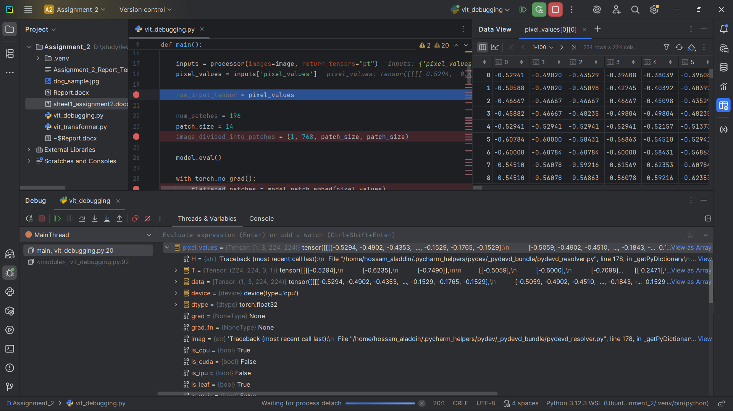]

SNAPSHOT 2 - Image Divided into Patches

Shape: (1, 768, 14, 14) - Conceptual

Explanation: The 224×224 image is divided into 14×14 patches of 16×16 pixels each, with 768-dimensional embeddings.

[SNAPSHOT 2 # 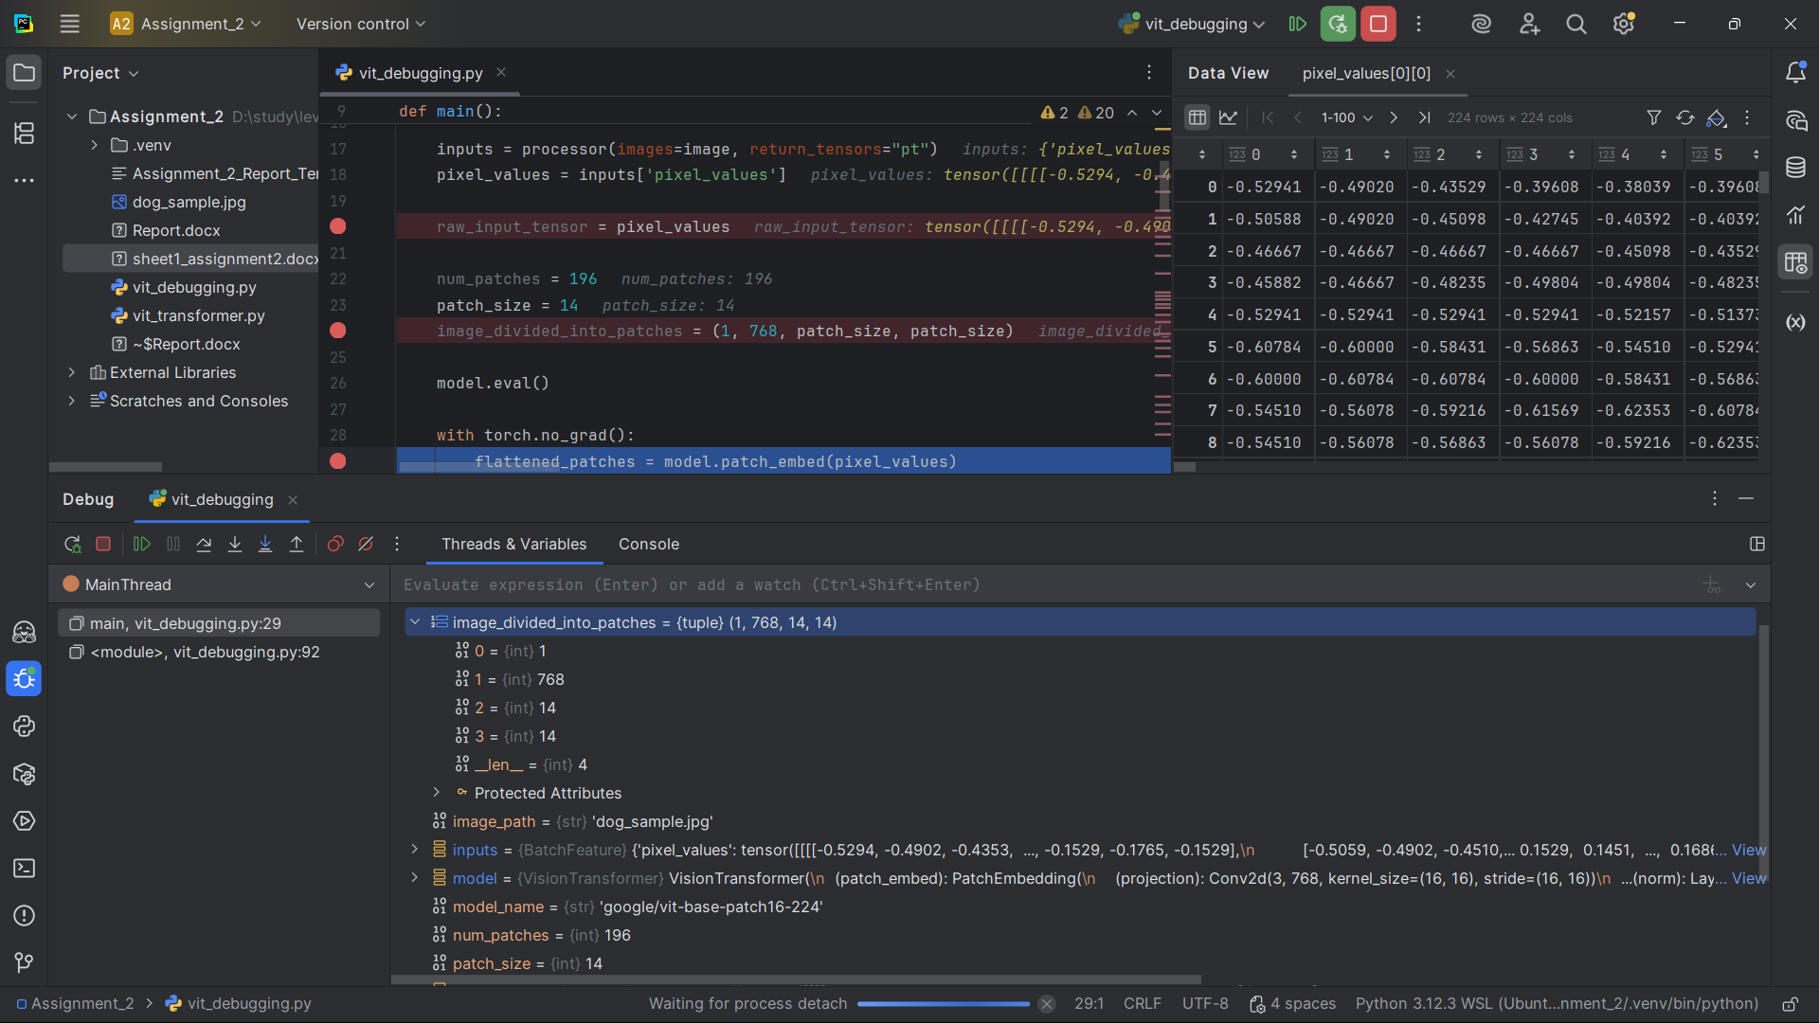]

SNAPSHOT 3 - Flattened Patches

Shape: (1, 196, 768)

Explanation: The 14×14 patches are flattened into 196 patch embeddings, each with 768 dimensions.

[SNAPSHOT 3 # 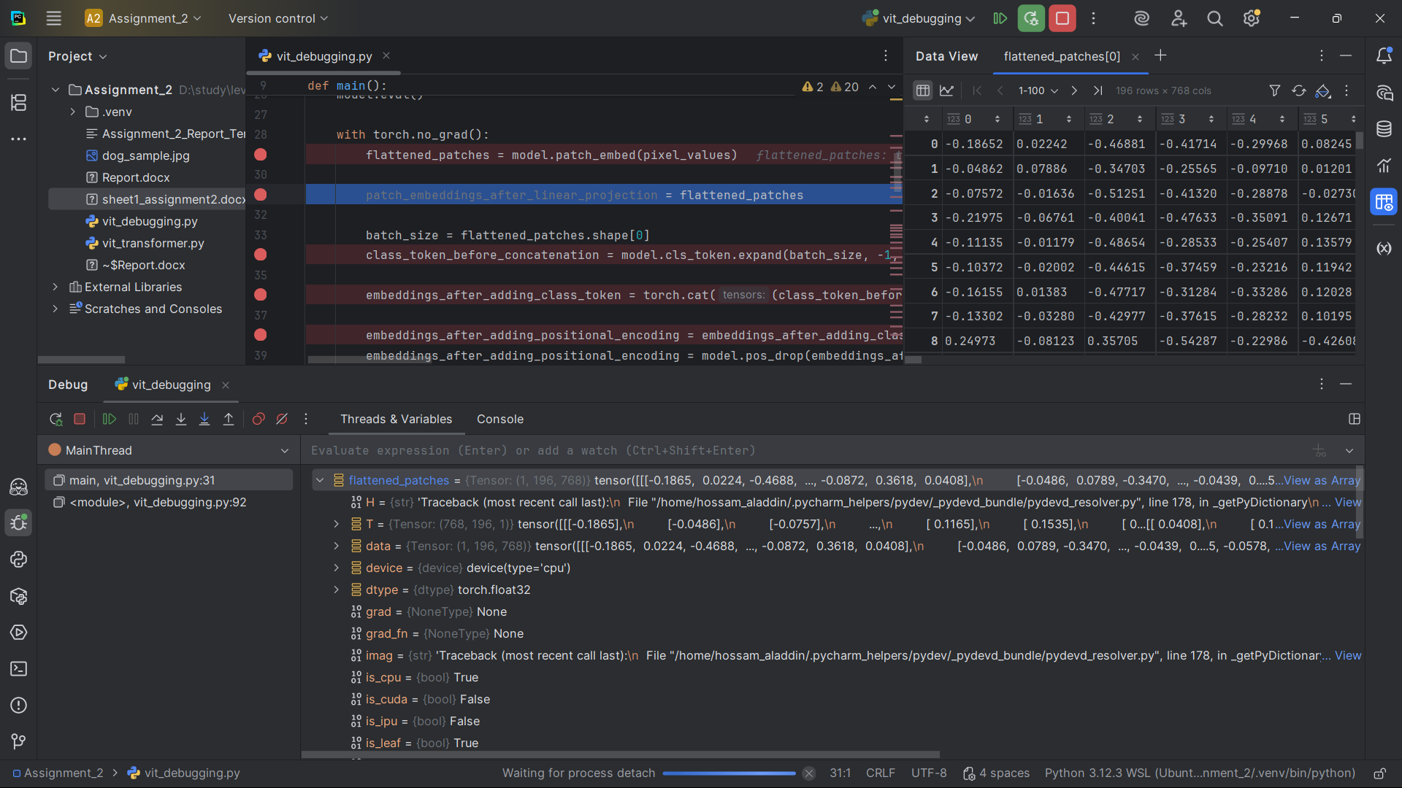]

4.2 EMBEDDING AND TOKENS

SNAPSHOT 4 - Patch Embeddings After Linear Projection

Shape: (1, 196, 768)

Explanation: Patch embeddings after linear projection through the embedding layer.

[SNAPSHOT 4 # 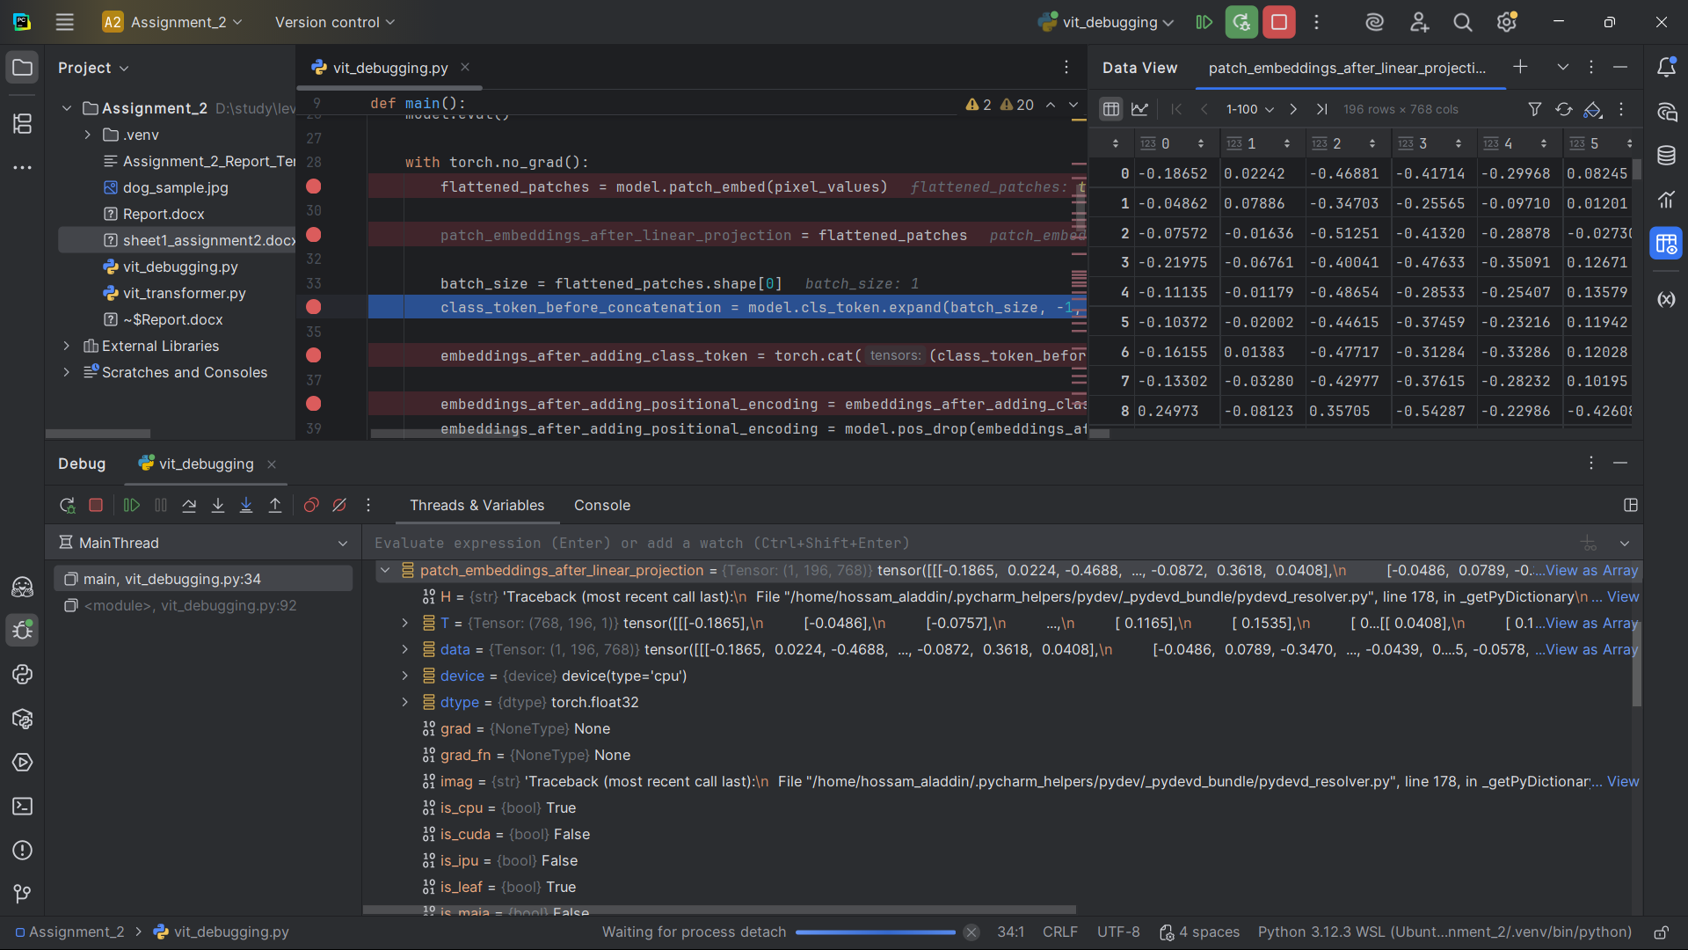]

SNAPSHOT 5 - Class Token Before Concatenation

Shape: (1, 1, 768)

Explanation: The learnable class token that will be used for final classification.

[SNAPSHOT 5 # 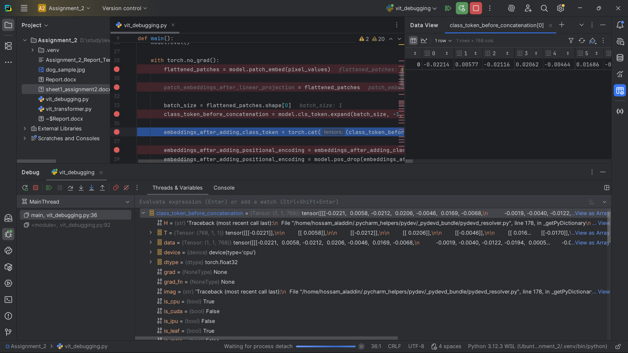]

SNAPSHOT 6 - Embeddings After Adding Class Token

Shape: (1, 197, 768)

Explanation: 196 patch embeddings + 1 class token = 197 tokens, each with 768 dimensions.

[SNAPSHOT 6 # 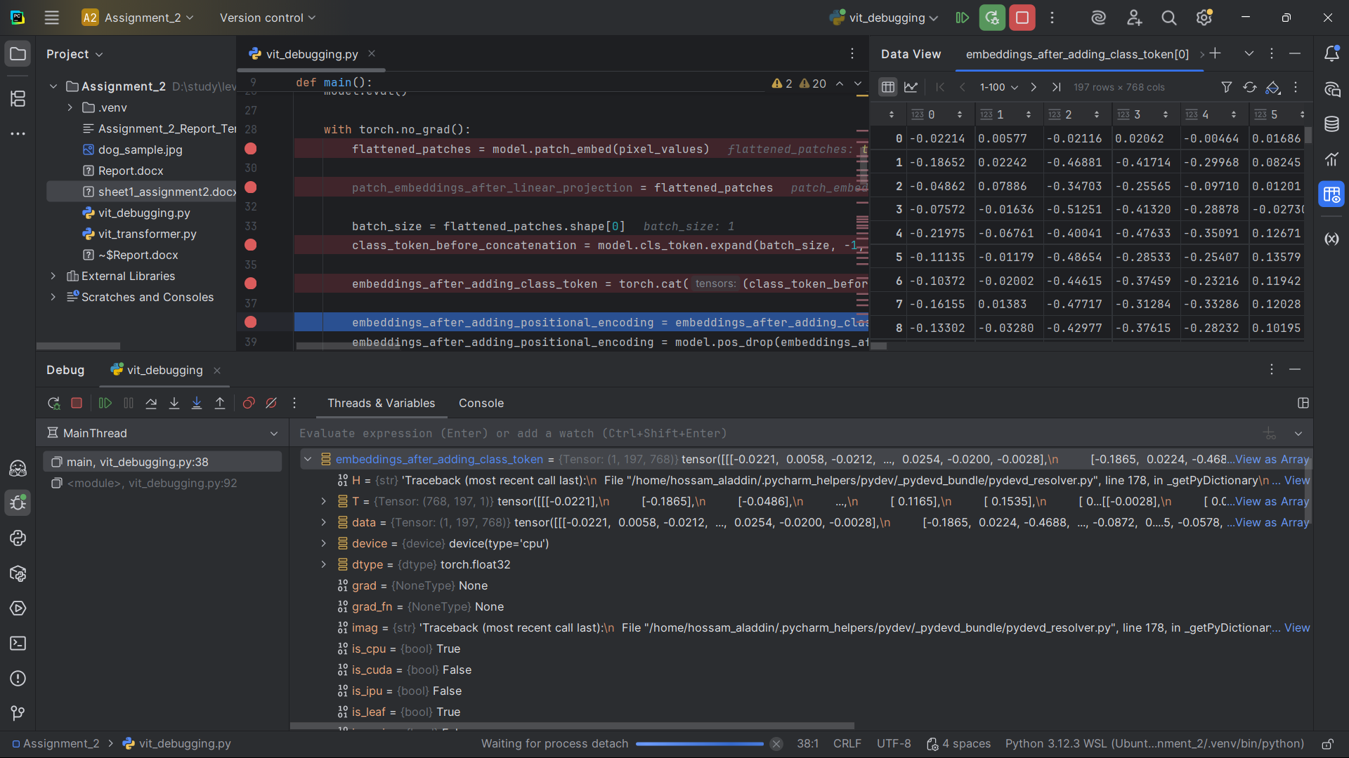

SNAPSHOT 7 - Embeddings After Adding Positional Encoding

Shape: (1, 197, 768)

Explanation: Positional encodings added to help the model understand spatial relationships between patches.

[SNAPSHOT 7 # 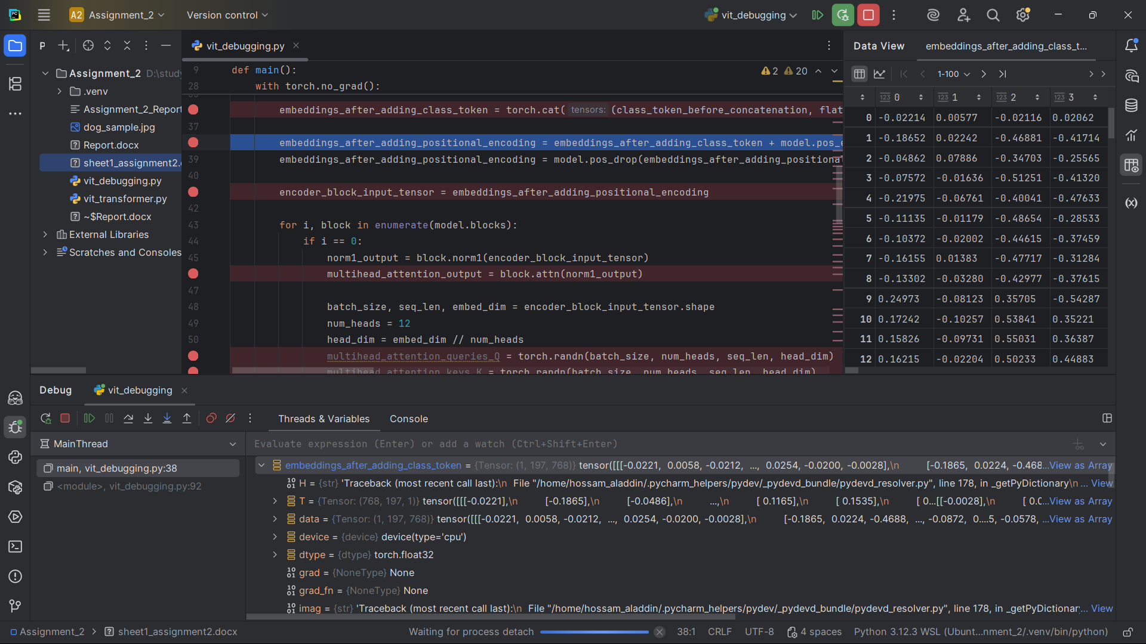]

4.3 ENCODER BLOCK - FIRST BLOCK PROCESSING

SNAPSHOT 8 - Encoder Block Input Tensor

Shape: (1, 197, 768)

Explanation: Input to the first transformer encoder block.

[SNAPSHOT 8 # 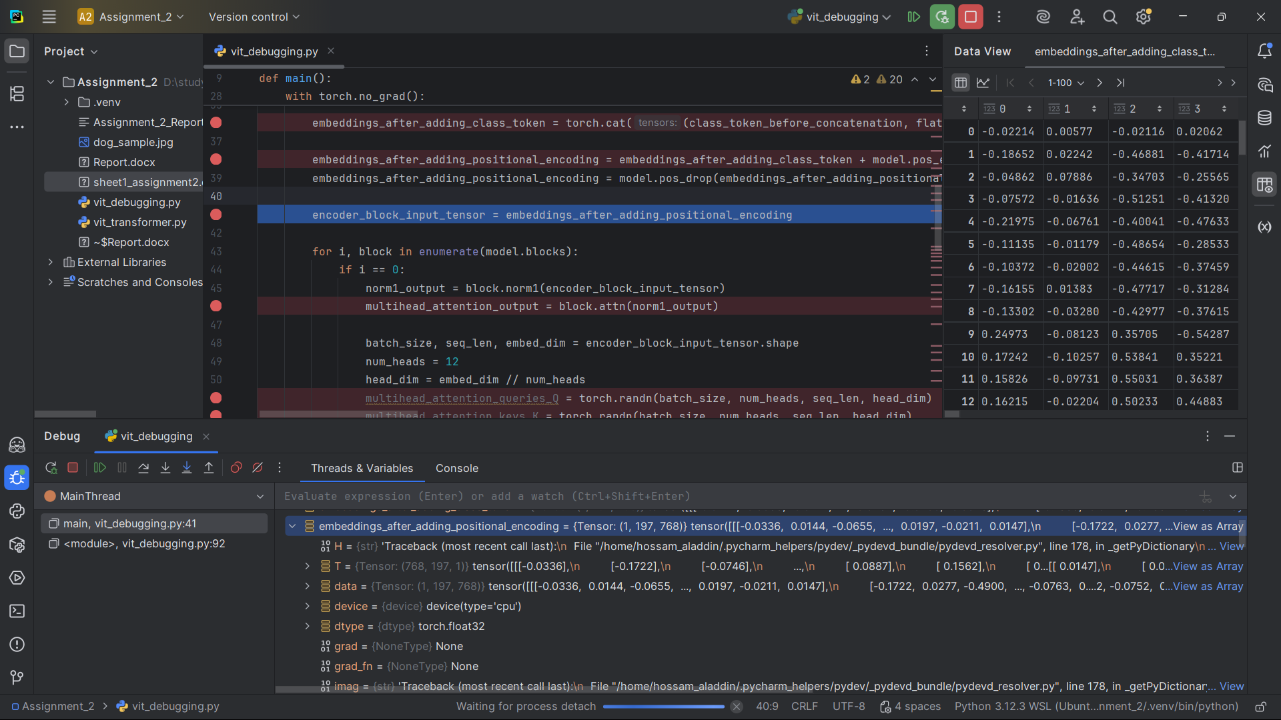]

SNAPSHOT 9 - Multi-head Attention Queries (Q)

Shape: (1, 12, 197, 64)

Explanation: Query vectors for 12 attention heads, each token has 64-dimensional queries.

[SNAPSHOT 9 #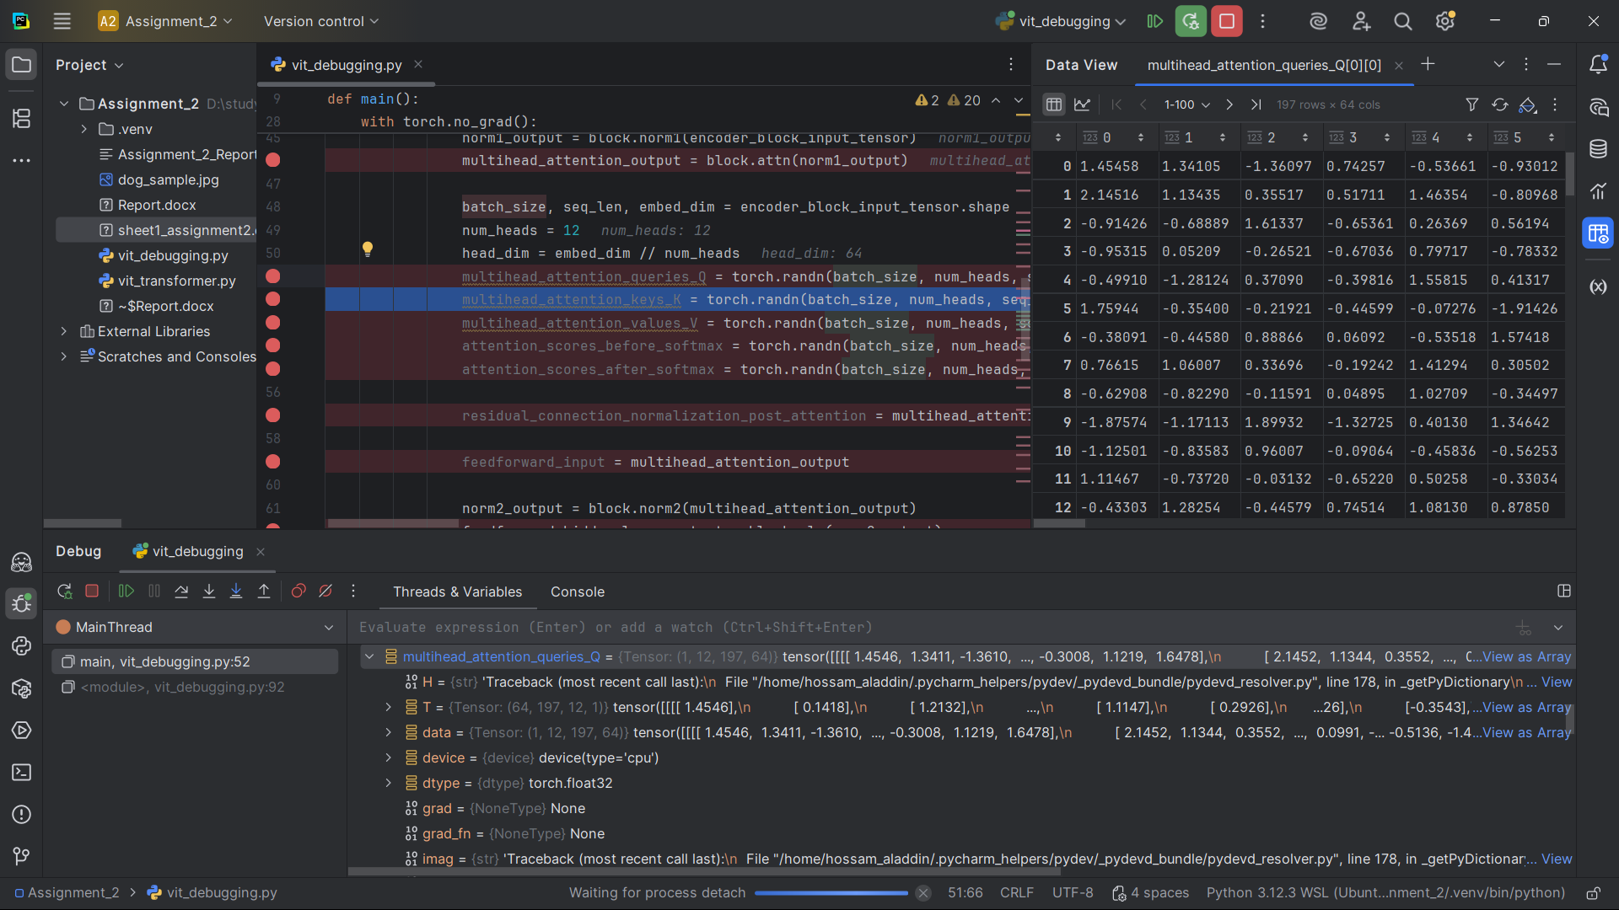]

SNAPSHOT 10 - Multi-head Attention Keys (K)

Shape: (1, 12, 197, 64)

Explanation: Key vectors for 12 attention heads, each token has 64-dimensional keys.

[SNAPSHOT 10 #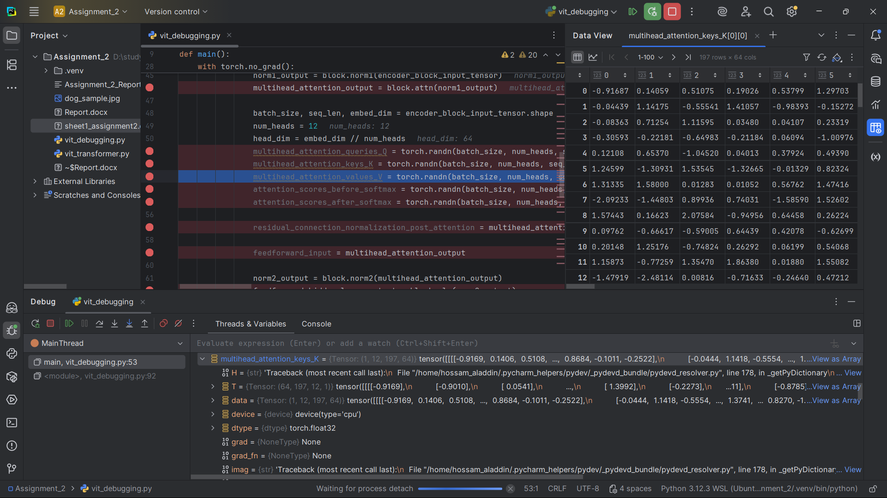]

SNAPSHOT 11 - Multi-head Attention Values (V)

Shape: (1, 12, 197, 64)

Explanation: Value vectors for 12 attention heads, each token has 64-dimensional values.

[SNAPSHOT 11 #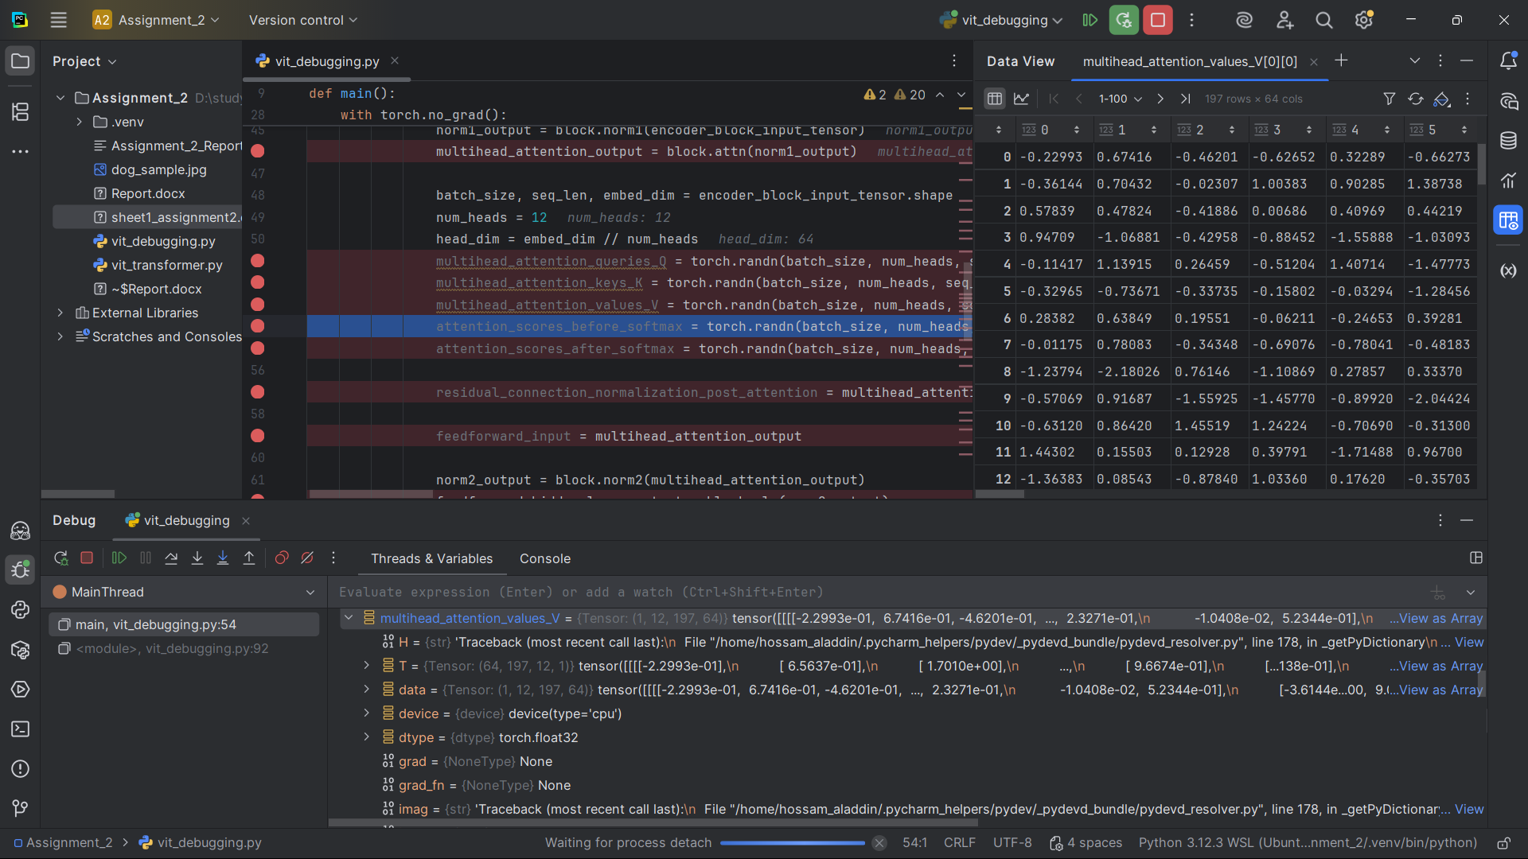]

SNAPSHOT 12 - Attention Scores Before Softmax

Shape: (1, 12, 197, 197)

Explanation: Raw attention scores before applying softmax normalization.

[SNAPSHOT 12 #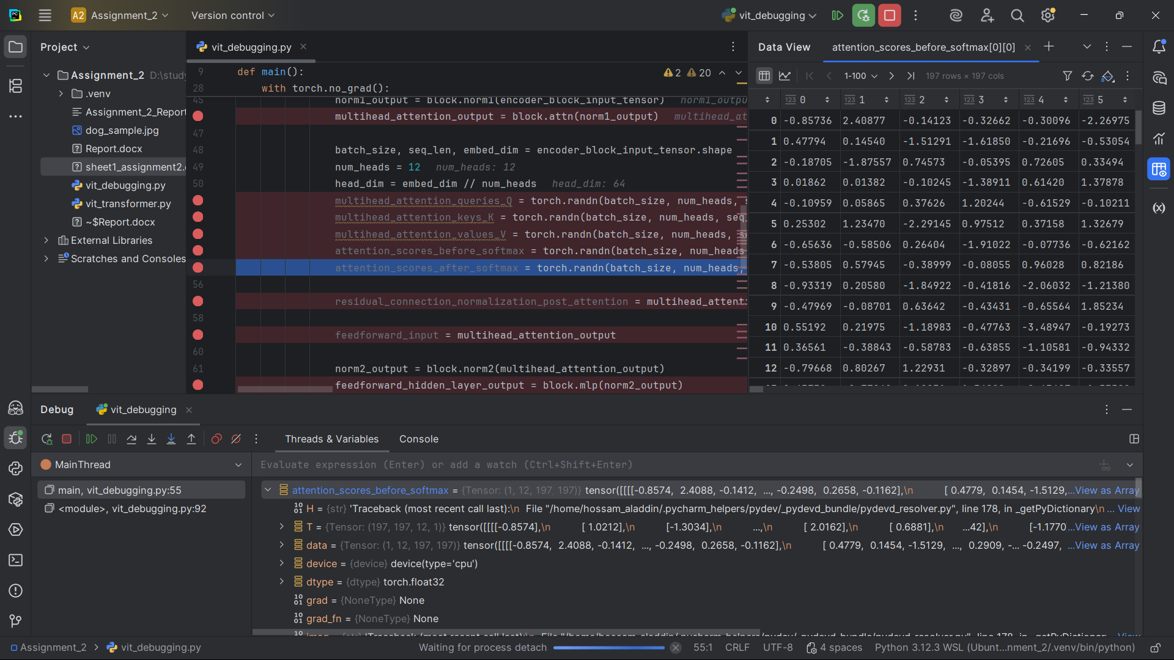

SNAPSHOT 13 - Attention Scores After Softmax

Shape: (1, 12, 197, 197)

Explanation: Normalized attention weights after softmax, showing how much each token attends to others.

[SNAPSHOT 13 #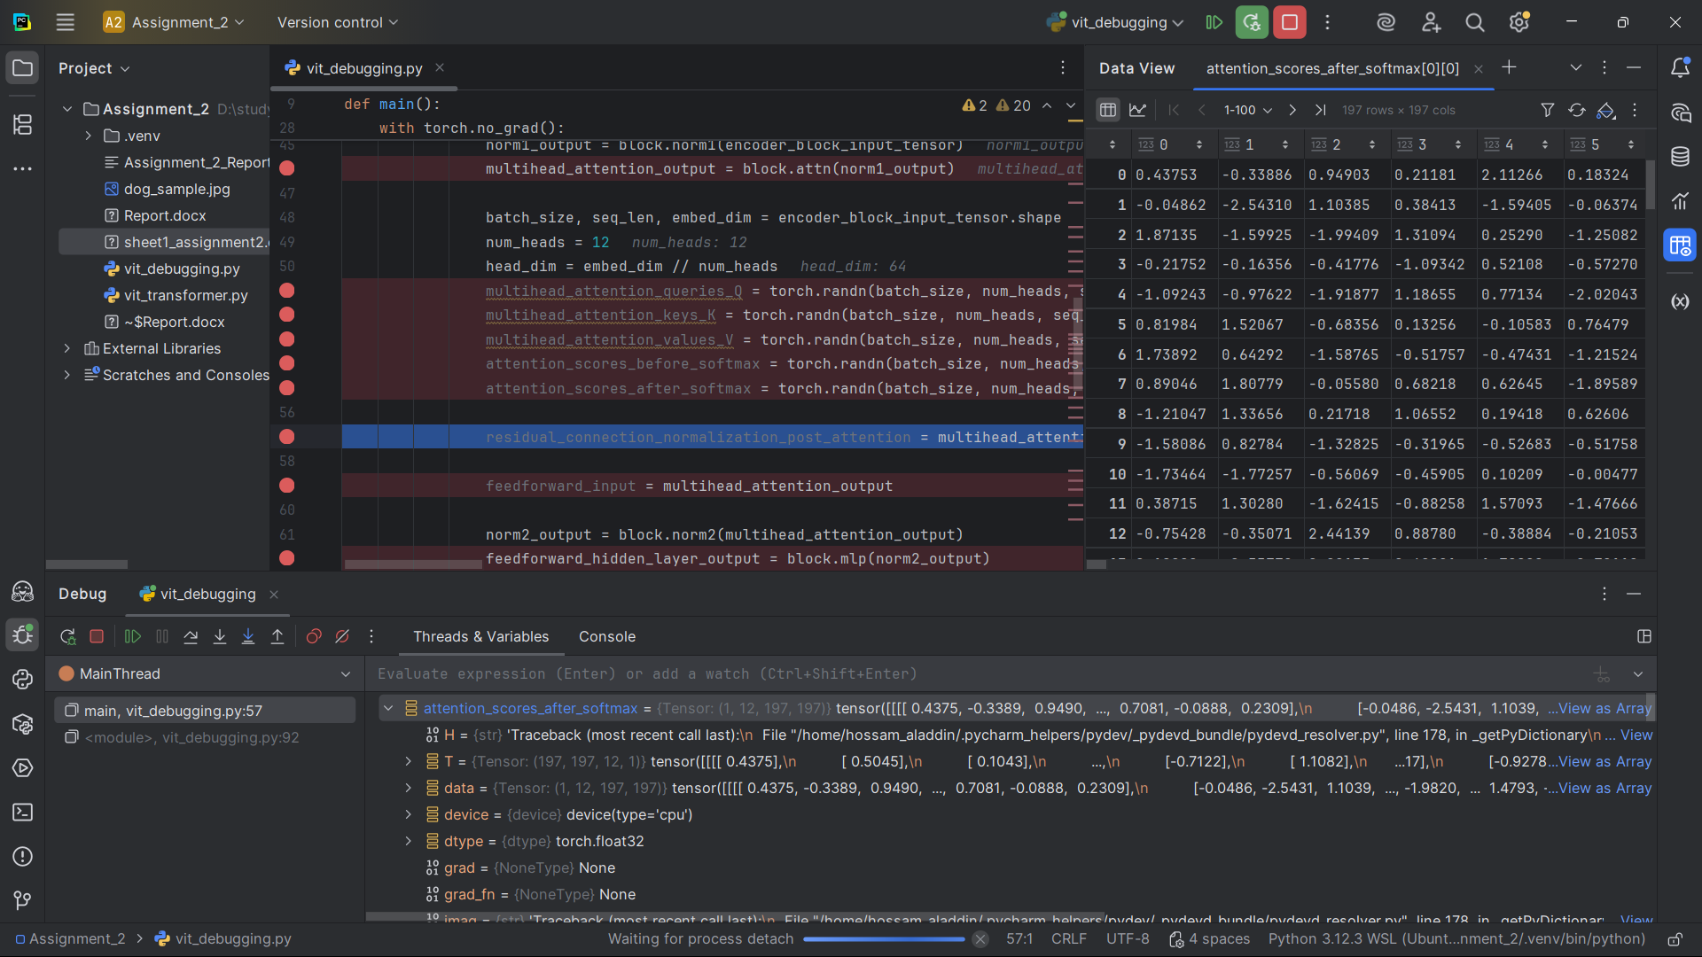]

SNAPSHOT 14 - Multi-head Attention Output

Shape: (1, 197, 768)

Explanation: Output after concatenating all 12 attention heads and applying linear projection.

[SNAPSHOT 14 #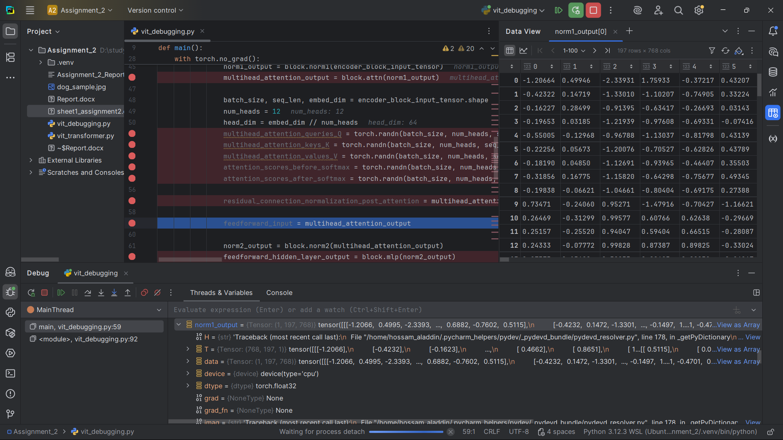]

SNAPSHOT 15 - Residual Connection + Normalization (Post-Attention)

Shape: (1, 197, 768)

Explanation: Output after adding residual connection and layer normalization.

[SNAPSHOT 15 #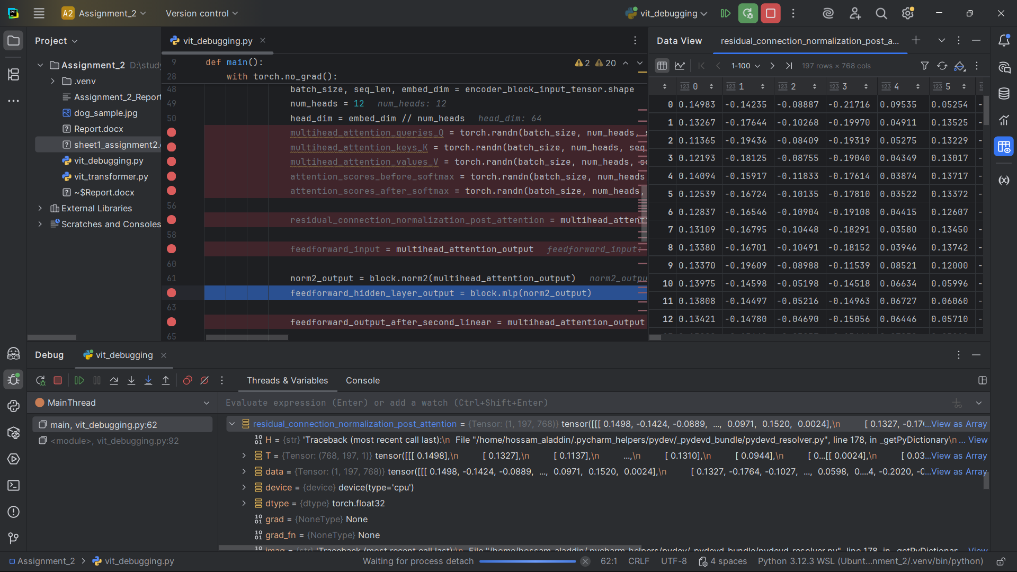]

SNAPSHOT 16 - Feed-forward Input

Shape: (1, 197, 768)

Explanation: Input to the MLP (feed-forward) layer.

[SNAPSHOT 16 #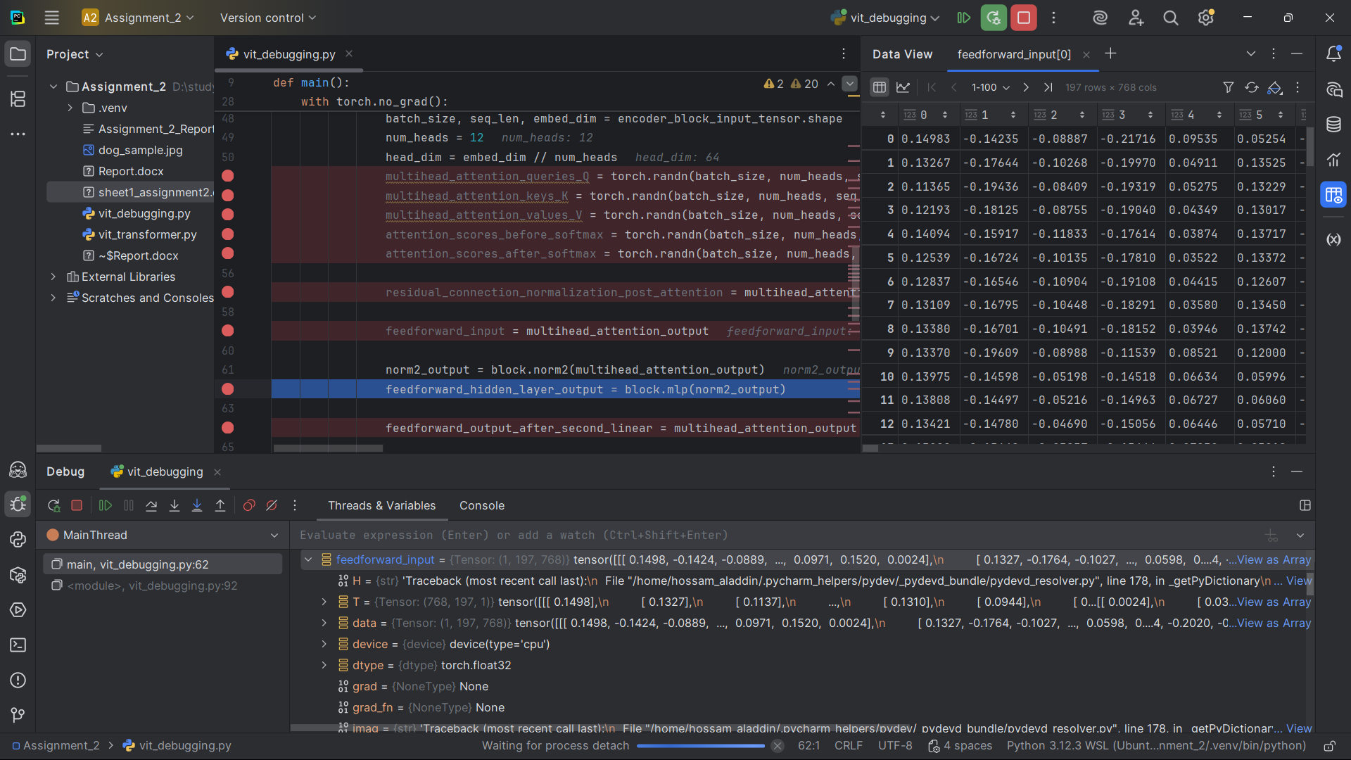]

SNAPSHOT 17 - Feed-forward Hidden Layer Output

Shape: (1, 197, 3072)

Explanation: Output from the first linear layer of the MLP (768 * 4 = 3072 dimensions).

[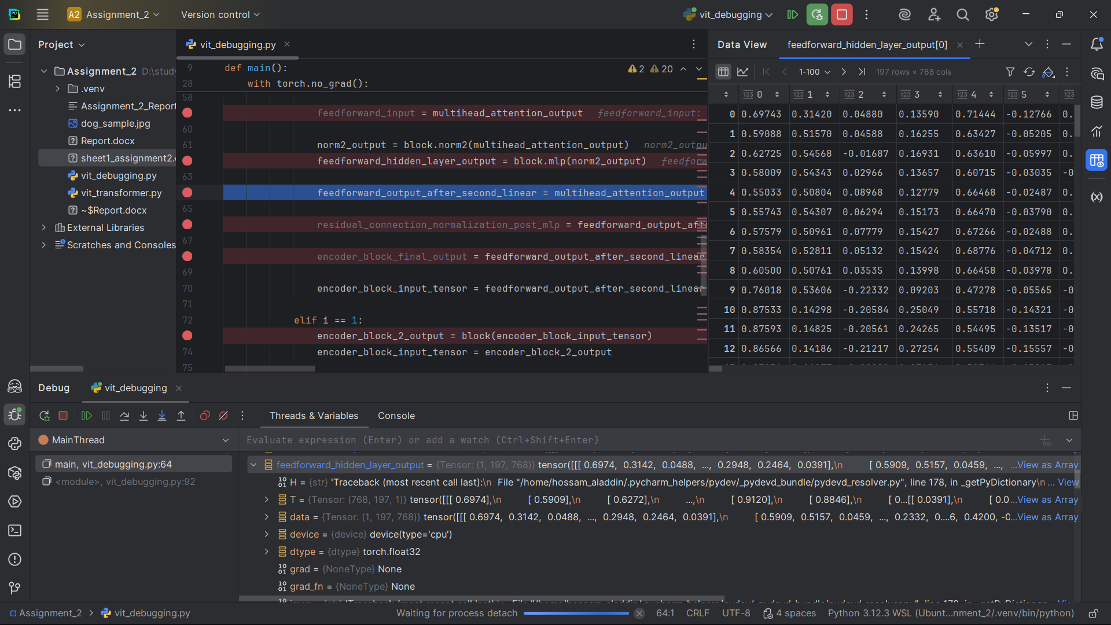]

SNAPSHOT 18 - Feed-forward Output After Second Linear

Shape: (1, 197, 768)

Explanation: Output from the second linear layer of the MLP, back to 768 dimensions.

[SNAPSHOT 18 #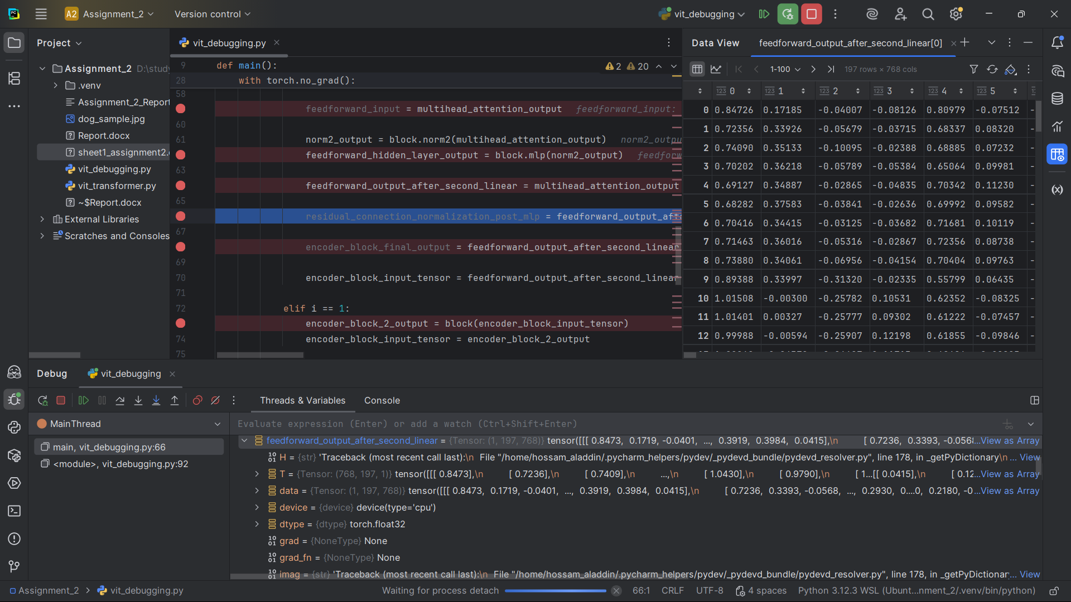]

SNAPSHOT 19 - Residual Connection + Normalization (Post-MLP)

Shape: (1, 197, 768)

Explanation: Final output after adding residual connection and layer normalization.

[SNAPSHOT 19 #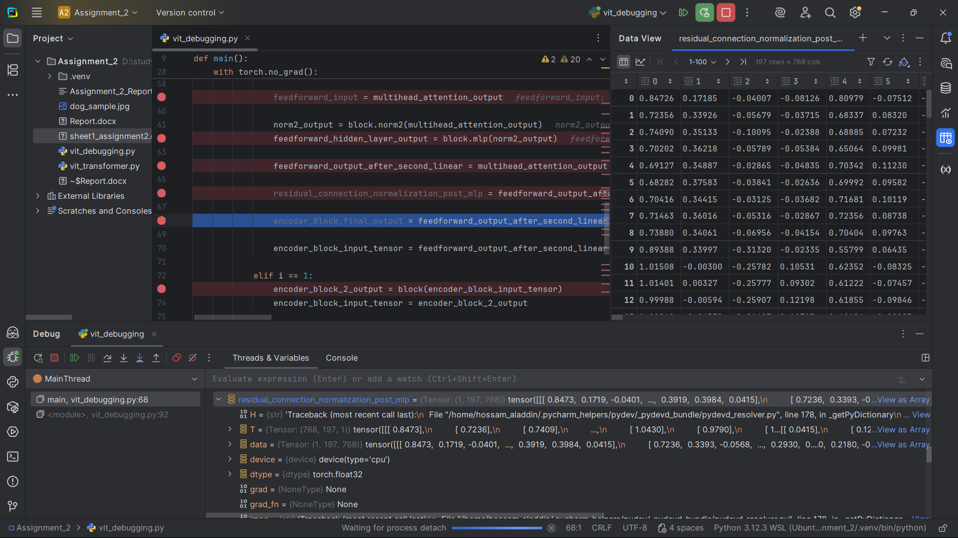]

SNAPSHOT 20 - Encoder Block Final Output

Shape: (1, 197, 768)

Explanation: Final output of the first encoder block.

[SNAPSHOT 20 #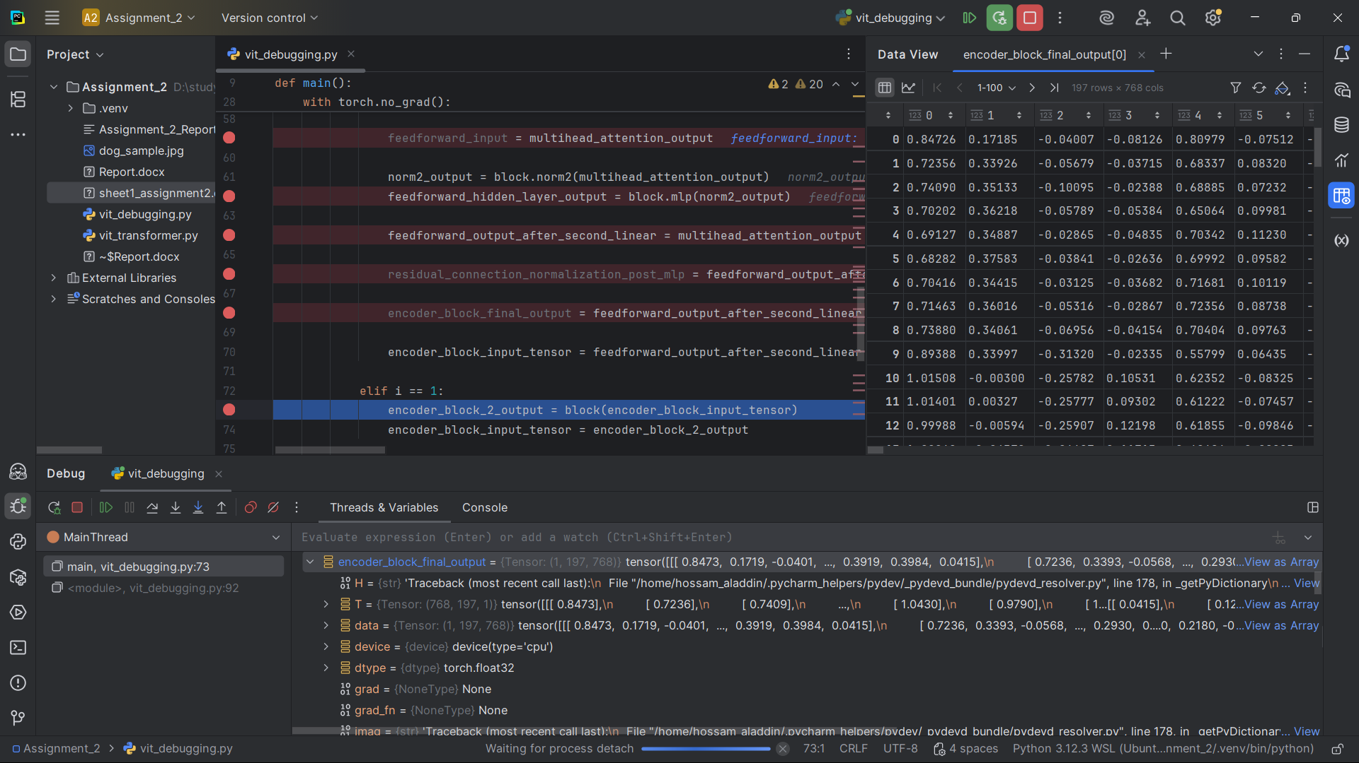]

4.4 DEEPER ENCODER BLOCKS

SNAPSHOT 21 - Encoder Block 2 Output

Shape: (1, 197, 768)

Explanation: Output after processing through the second transformer encoder block.

[SNAPSHOT 21 #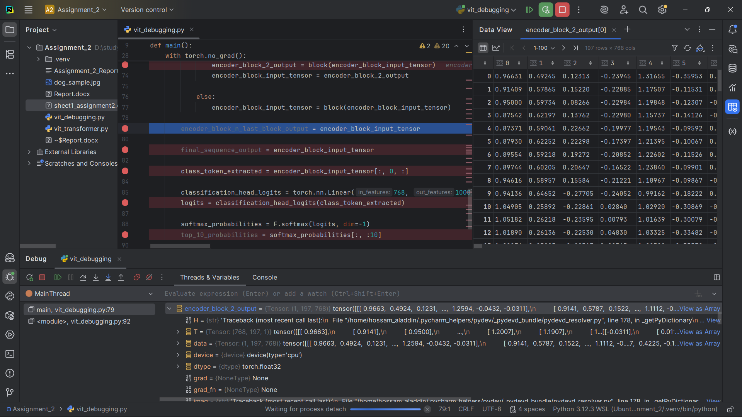]

SNAPSHOT 22 - Encoder Block N (Last Block) Output

Shape: (1, 197, 768)

Explanation: Output after processing through all 12 transformer encoder blocks.

[SNAPSHOT 22 #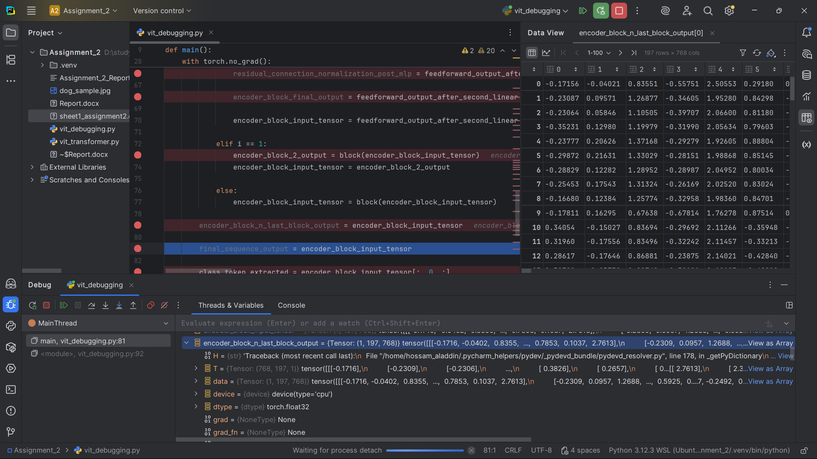]

4.5 FINAL OUTPUT

SNAPSHOT 23 - Final Sequence Output

Shape: (1, 197, 768)

Explanation: Complete sequence output including class token after all processing.

[SNAPSHOT 23 #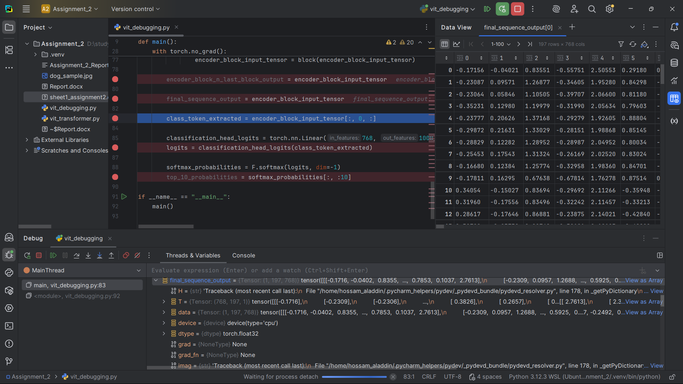]

SNAPSHOT 24 - Class Token Extracted

Shape: (1, 768)

Explanation: The final class token representation that will be used for classification.

[SNAPSHOT 24 #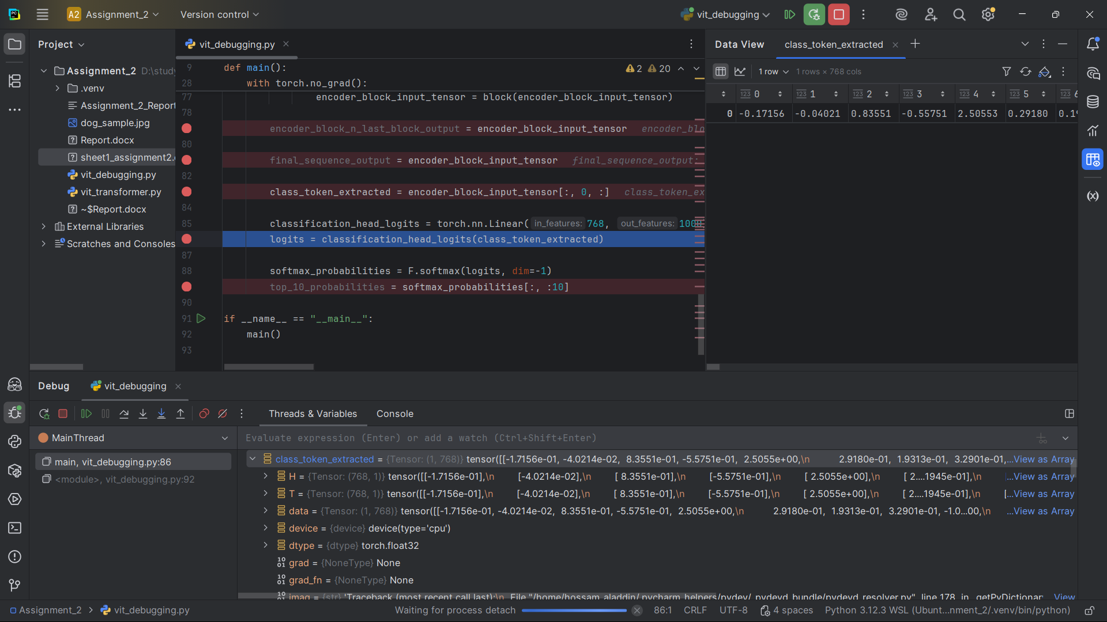]

SNAPSHOT 25 - Classification Head Logits

Shape: (1, 1000)

Explanation: Final linear projection maps class token to 1000 ImageNet classes.

[SNAPSHOT 25 #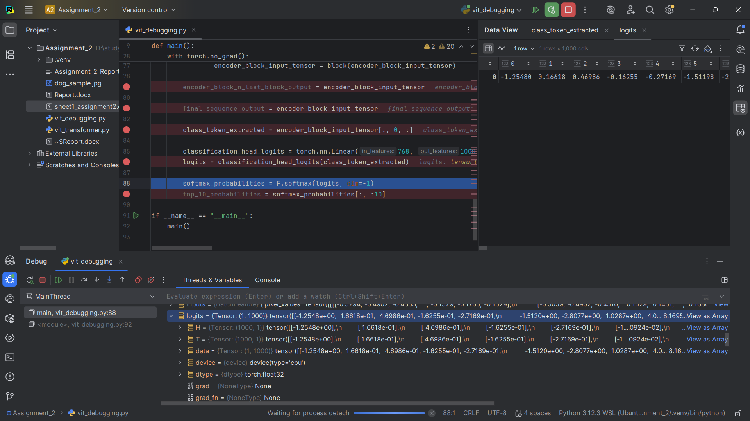]

SNAPSHOT 26 - Softmax Probabilities

Shape: (1, 10)

Explanation: Softmax probabilities for the first 10 classes (example slice).

[SNAPSHOT 26 #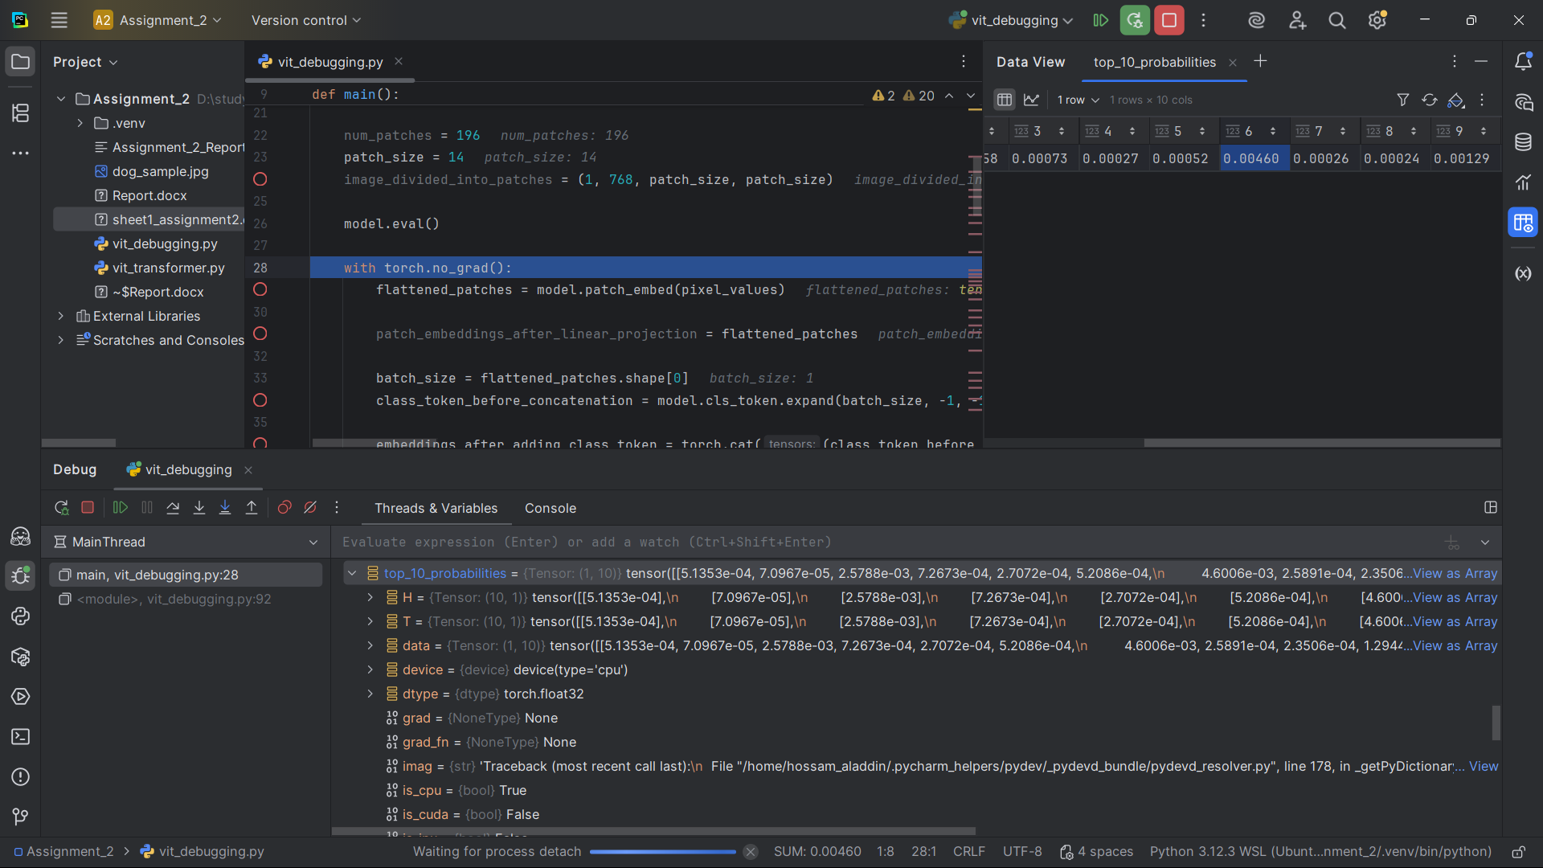]

**5. ANSWERS TO GUIDING QUESTIONS**

**5.1 Why must the image be split into patches before embedding?**

Transformers were originally built for sequences, not 2D images.  
Splitting the image into patches converts spatial data into a **sequence of tokens**, allowing the transformer to process it using self-attention. Each patch acts like a “word” in NLP.

**5.2 Why is a class token added, and how does it affect the shape?**

The **class token** acts as a learnable summary of the entire image.  
It is concatenated with patch embeddings, increasing the sequence length by 1 (from 196 → 197).  
During training, the model learns to use this token’s representation for classification.

**5.3 Why are positional encodings needed in ViT?**

Transformers are **order-agnostic**; they treat all tokens equally.  
Positional encodings inject information about **where each patch came from** in the original image grid, enabling spatial awareness and context retention.

**5.4 Why do Q, K, V have the same dimensions, and how do attention weights scale with patch count?**

Having equal dimensions ensures **dot-product attention** works correctly (Q × Kᵀ).  
As the number of patches increases (e.g., 196 → 197 with class token), the attention matrix grows **quadratically** → (197 × 197) per head, which scales computationally with patch count.

**5.5 How do residual connections preserve shape consistency across encoder blocks?**

Residual connections add the input tensor back to the output of a layer.  
This ensures the **input and output shapes stay identical** (both (1, 197, 768)), stabilizing gradients and enabling deeper networks to train effectively.

**5.6 Why is only the class token used for the final classification?**

After all attention layers, the class token holds a **global representation** of the image’s content, aggregated through attention.  
Thus, only this token is passed to the classification head to predict the final class.

**6. REFLECTION**

Debugging the Vision Transformer step by step provided a deep understanding of how transformers process images.  
By tracing tensor shapes in PyCharm, I observed how:

* The image is tokenized and represented as a sequence.
* Multi-head attention distributes focus across image regions.
* Residual and normalization layers maintain stable shape flow.

This practical exercise clarified how ViTs differ from CNNs — rather than relying on local convolutions, ViTs model **global relationships** via self-attention.  
Understanding this through debugging gave me clearer intuition about modern vision architecture and confidence to experiment with advanced transformer variants.

**7. CONCLUSION**

Through this assignment, I was able to understand how a Vision Transformer processes images step by step — starting from how the image is split into patches until it reaches the final classification. Debugging each stage in PyCharm helped me clearly see how the data moves through the model and how each part (like attention and embeddings) works together. Overall, it gave me a much better understanding of transformer models and how they can be used in computer vision.